**DIGITAL SYSTEM PRACTICUM REPORT 9 : DECODER**



NIM : L200184134

NAME : MAHARDHIKA BATHIARTO DIM ZARITA

**INFORMATION TECHNOLOGY**

**FACULTY OF COMMUNICATION AND INFORMATICS MUHAMMADIYAH UNIVERSITY OF SURAKARTA 2019**

***# exercise 1***

1. 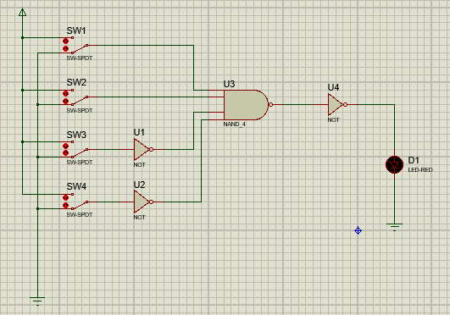**Make a simple decoder**
2. **Truth table**

|  |  |  |  |  |
| --- | --- | --- | --- | --- |
| **A** | **B** | **C** | **D** | **F** |
| 0 | 0 | 0 | 0 | **0** |
| 1 | 0 | 0 | 0 | **0** |
| 0 | 1 | 0 | 0 | **0** |
| 1 | 1 | 0 | 0 | **1** |

|  |  |  |  |  |
| --- | --- | --- | --- | --- |
| 0 | 0 | 1 | 0 | **0** |
| 1 | 0 | 1 | 0 | **0** |
| 0 | 1 | 1 | 0 | **0** |
| 1 | 1 | 1 | 0 | **0** |
| 0 | 0 | 0 | 1 | **0** |
| 1 | 0 | 0 | 1 | **0** |
| 0 | 1 | 0 | 1 | **0** |
| 1 | 1 | 0 | 1 | **0** |
| 0 | 0 | 1 | 1 | **0** |
| 1 | 0 | 1 | 1 | **0** |
| 0 | 1 | 1 | 1 | **0** |
| 1 | 1 | 1 | 1 | **0** |

1. **Decoder (F) just working (ON) when : A = 1 B = 1 C = 0 D = 0**
2. **Decoder that have output**

F = 1

A = 0 B = 1 C = 1 D = 1 (F = A’BCD)

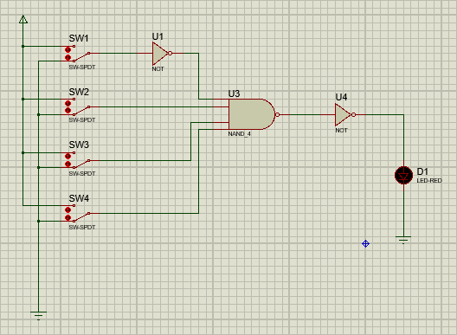

***# exercise 2***

1. 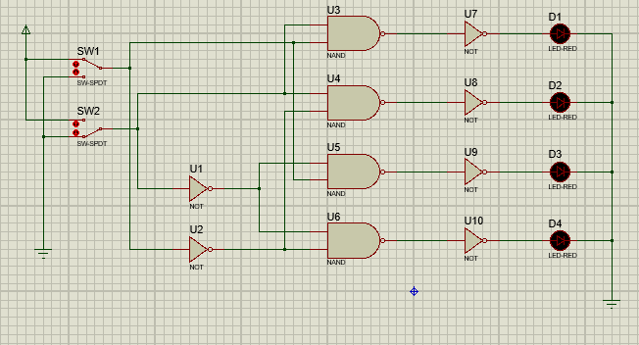**Make a combination of logic gate**
2. **Truth table**

|  |  |  |  |  |  |
| --- | --- | --- | --- | --- | --- |
| **Input** | | **Output LED** | | | |
| **SW1** | **SW2** | **D1** | **D2** | **D3** | **D4** |
| **0** | **0** | **0** | **0** | **0** | **1** |
| **0** | **1** | **0** | **1** | **0** | **0** |
| **1** | **0** | **0** | **0** | **1** | **0** |
| **1** | **1** | **1** | **0** | **0** | **0** |

1. **Each diode (LED) shows the output of a combination circuit : D1 = *SW1 . SW2***

**D2 =** *SW1 . SW2* **D3 =** *SW1 . SW2* **D4 =** *SW1 . SW2*

***# exercise 3***

1. 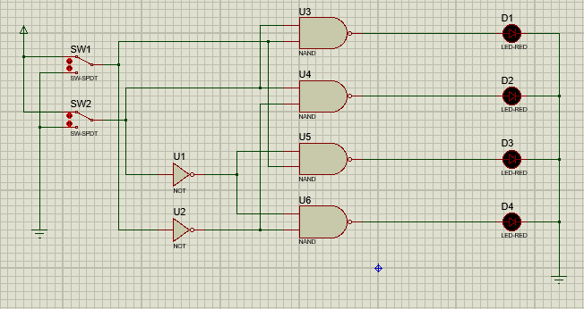**Make a combination of logic gate**
2. **Truth table**

|  |  |  |  |  |  |
| --- | --- | --- | --- | --- | --- |
| **Input** | | **Output LED** | | | |
| **SW1** | **SW2** | **D1** | **D2** | **D3** | **D4** |
| **0** | **0** | 1 | 1 | 1 | 0 |
| **0** | **1** | 1 | 0 | 1 | 1 |
| **1** | **0** | 1 | 1 | 0 | 1 |
| **1** | **1** | 0 | 1 | 1 | 1 |

1. **Each diode (LED) shows the output of a combination circuit : D1 = *SW1 . SW2***

**D2 =** *SW1 . SW2* **D3 =** *SW1 . SW2* **D4 =** *SW1 . SW2*

1. **Conclusion**
   * Exercise 2 use AND gate
   * Exercise 3 use NAND gate

➔ **NOT** affects the output of the LED.

the output of the LED using **NOT** will be inversely proportional to the output of the LED that does not use **NOT**

***# exercise 4***

1. **Circuit**
   * **Anode LED circuit**

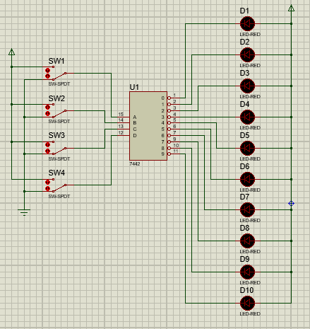

* + 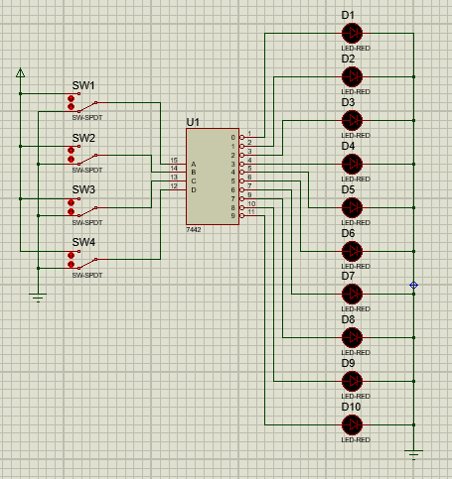**Cathode LED circuit**

1. **Truth table**
   * **Anode LED circuit**

|  |  |  |  |  |  |  |  |  |  |  |  |  |  |
| --- | --- | --- | --- | --- | --- | --- | --- | --- | --- | --- | --- | --- | --- |
| **Input** | | | | **Output** | | | | | | | | | |
| **SW4** | **SW3** | **SW2** | **SW1** | **0** | **1** | **2** | **3** | **4** | **5** | **6** | **7** | **8** | **9** |
| **0** | **0** | **0** | **0** | 1 | 0 | 0 | 0 | 0 | 0 | 0 | 0 | 0 | 0 |
| **0** | **0** | **0** | **1** | 0 | 1 | 0 | 0 | 0 | 0 | 0 | 0 | 0 | 0 |
| **0** | **0** | **1** | **0** | 0 | 0 | 1 | 0 | 0 | 0 | 0 | 0 | 0 | 0 |
| **0** | **0** | **1** | **1** | 0 | 0 | 0 | 1 | 0 | 0 | 0 | 0 | 0 | 0 |
| **0** | **1** | **0** | **0** | 0 | 0 | 0 | 0 | 1 | 0 | 0 | 0 | 0 | 0 |
| **0** | **1** | **0** | **1** | 0 | 0 | 0 | 0 | 0 | 1 | 0 | 0 | 0 | 0 |
| **0** | **1** | **1** | **0** | 0 | 0 | 0 | 0 | 0 | 0 | 1 | 0 | 0 | 0 |
| **0** | **1** | **1** | **1** | 0 | 0 | 0 | 0 | 0 | 0 | 0 | 1 | 0 | 0 |

|  |  |  |  |  |  |  |  |  |  |  |  |  |  |
| --- | --- | --- | --- | --- | --- | --- | --- | --- | --- | --- | --- | --- | --- |
| **1** | **0** | **0** | **0** | 0 | 0 | 0 | 0 | 0 | 0 | 0 | 0 | 1 | 0 |
| **1** | **0** | **0** | **1** | 0 | 0 | 0 | 0 | 0 | 0 | 0 | 0 | 0 | 1 |
| **1** | **0** | **1** | **0** | 0 | 0 | 0 | 0 | 0 | 0 | 0 | 0 | 0 | 0 |
| **1** | **0** | **1** | **1** | 0 | 0 | 0 | 0 | 0 | 0 | 0 | 0 | 0 | 0 |
| **1** | **1** | **0** | **0** | 0 | 0 | 0 | 0 | 0 | 0 | 0 | 0 | 0 | 0 |
| **1** | **1** | **0** | **1** | 0 | 0 | 0 | 0 | 0 | 0 | 0 | 0 | 0 | 0 |
| **1** | **1** | **1** | **0** | 0 | 0 | 0 | 0 | 0 | 0 | 0 | 0 | 0 | 0 |
| **1** | **1** | **1** | **1** | 0 | 0 | 0 | 0 | 0 | 0 | 0 | 0 | 0 | 0 |

* + **Cathode LED circuit**

|  |  |  |  |  |  |  |  |  |  |  |  |  |  |
| --- | --- | --- | --- | --- | --- | --- | --- | --- | --- | --- | --- | --- | --- |
| **Input** | | | | **Output** | | | | | | | | | |
| **SW4** | **SW3** | **SW2** | **SW1** | **0** | **1** | **2** | **3** | **4** | **5** | **6** | **7** | **8** | **9** |
| **0** | **0** | **0** | **0** | 0 | 1 | 1 | 1 | 1 | 1 | 1 | 1 | 1 | 1 |
| **0** | **0** | **0** | **1** | 1 | 0 | 1 | 1 | 1 | 1 | 1 | 1 | 1 | 1 |
| **0** | **0** | **1** | **0** | 1 | 1 | 0 | 1 | 1 | 1 | 1 | 1 | 1 | 1 |
| **0** | **0** | **1** | **1** | 1 | 1 | 1 | 0 | 1 | 1 | 1 | 1 | 1 | 1 |
| **0** | **1** | **0** | **0** | 1 | 1 | 1 | 1 | 0 | 1 | 1 | 1 | 1 | 1 |
| **0** | **1** | **0** | **1** | 1 | 1 | 1 | 1 | 1 | 0 | 1 | 1 | 1 | 1 |
| **0** | **1** | **1** | **0** | 1 | 1 | 1 | 1 | 1 | 1 | 0 | 1 | 1 | 1 |
| **0** | **1** | **1** | **1** | 1 | 1 | 1 | 1 | 1 | 1 | 1 | 0 | 1 | 1 |
| **1** | **0** | **0** | **0** | 1 | 1 | 1 | 1 | 1 | 1 | 1 | 1 | 0 | 1 |
| **1** | **0** | **0** | **1** | 1 | 1 | 1 | 1 | 1 | 1 | 1 | 1 | 1 | 0 |
| **1** | **0** | **1** | **0** | 1 | 1 | 1 | 1 | 1 | 1 | 1 | 1 | 1 | 1 |
| **1** | **0** | **1** | **1** | 1 | 1 | 1 | 1 | 1 | 1 | 1 | 1 | 1 | 1 |
| **1** | **1** | **0** | **0** | 1 | 1 | 1 | 1 | 1 | 1 | 1 | 1 | 1 | 1 |
| **1** | **1** | **0** | **1** | 1 | 1 | 1 | 1 | 1 | 1 | 1 | 1 | 1 | 1 |
| **1** | **1** | **1** | **0** | 1 | 1 | 1 | 1 | 1 | 1 | 1 | 1 | 1 | 1 |
| **1** | **1** | **1** | **1** | 1 | 1 | 1 | 1 | 1 | 1 | 1 | 1 | 1 | 1 |

***# additional assignment***

